**Chapter 6**

**Vector Calculus**

**6.8 The Divergence Theorem**

**Section Exercises**

**For the following exercises, use a computer algebraic system (CAS) and the divergence theorem to evaluate surface integral  for the given choice of F and the boundary surface *S.* For each closed surface, assume N is the outward unit normal vector.**

1. **[T] ***S* is the surface of cube 

Answer: 

1. **[T]** *S* is the surface of hemisphere  together with disk  in the *xy*-plane.

Answer: 

1. [T] S is the surface of the five faces of unit cube 

Answer: 

1. **[T]** *S* is the surface of paraboloid 

Answer: 

1. **[T]** *S* is the surface of sphere 

Answer: 

1. **[T]** *S* is the surface of the solid bounded by cylinder  and planes 

Answer: 

1. **[T] ***S* is the surface bounded above by sphere  and below by cone .. in spherical coordinates. (Think of *S* as the surface of an “ice cream cone.”)

Answer: 

1. **[T]** *S* is the surface bounded by cylinder  and planes 

Answer: 

1. **[T]** Surface integral  where *S* is the solid bounded by paraboloid  and plane , and 

Answer: 

1. Use the divergence theorem to calculate surface integral  where  and *S*is upper hemisphere  oriented upward.

Answer: 

1. Use the divergence theorem to calculate surface integral  where and S is the surface bounded by cylinder  and planes  and 

Answer: 

1. Use the divergence theorem to calculate surface integral  when  and *S* is the surface of the box with vertices 

Answer: 

1. Use the divergence theorem to calculate surface integral  when  and *S* is a part of paraboloid  that lies above plane  and is oriented upward.

Answer: 

1. **[T]** Use a CAS and the divergence theorem to calculate flux , where  and *S* is a sphere with center (0, 0) and radius 2.

Answer: 

1. Use the divergence theorem to compute the value of flux integral  where and *S* is the area of the region bounded by 

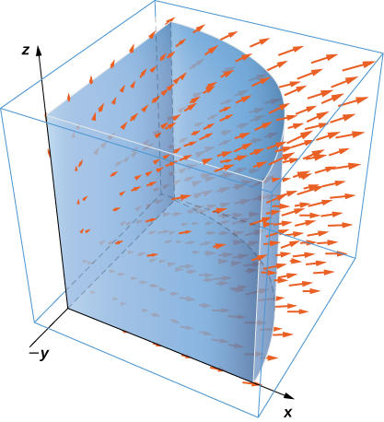

Answer: 

1. Use the divergence theorem to compute flux integral where and *S* consists of the union of paraboloid and disk  oriented outward. What is the flux through just the paraboloid?

Answer: 

1. Use the divergence theorem to compute flux integral  where and *S* is a part of cone  beneath top plane  oriented downward.

Answer: 

1. Use the divergence theorem to calculate surface integral  for  where *S* is the surface bounded by cylinder  and planes 

Answer: 

1. Consider  Let *E* be the solid enclosed by paraboloid  and plane  with normal vectors pointing outside *E*. Compute flux ***F*** across the boundary of *E* using the divergence theorem.

Answer: 

**For the following exercises, use a CAS along with the divergence theorem to compute the net outward flux for the fields across the given surfaces *S*.**

1. **[T]**  *S* is sphere 

Answer: 

1. **[T]**  *S* is the boundary of the tetrahedron in the first octant formed by plane 

Answer: 

1. **[T]**  *S* is sphere 

Answer: 

1. **[T]** *S* is the surface of paraboloid  for  plus its base in the *xy*-plane.

Answer: 

**For the following exercises, use a CAS and the divergence theorem to compute the net outward flux for the vector fields across the boundary of the given regions *D*.**

1. **[T]** *D* is the region between spheres of radius 2 and 4 centered at the origin.

Answer: 

1. **[T]** *D* is the region between spheres of radius 1 and 2

centered at the origin.

Answer: 

1. **[T]** *D* is the region in the first octant between planes  and 

Answer: 20

1. Let  Use the divergence theorem to calculate  where *S* is the surface of the cube with corners at  oriented outward.

Answer: 

1. Use the divergence theorem to find the outward flux of field  through the cube bounded by planes 

Answer: 

1. Let  and let *S* be hemisphere  together with disk  in the *xy*-plane. Use the divergence theorem.

Answer: 

1. Evaluate  where  and *S* is the surface consisting of all faces except the tetrahedron bounded by plane  and the coordinate planes, with outward unit normal vector **N**.

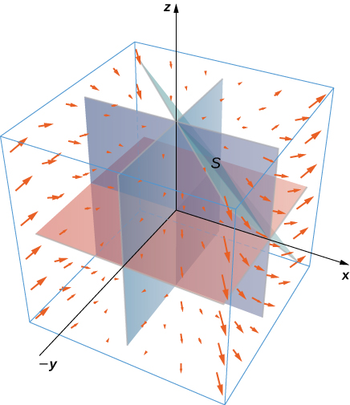

Answer: 

1. Find the net outward flux of field  across any smooth closed surface in  where *a*, *b*, and *c* are constants.

Answer: 

1. Use the divergence theorem to evaluate , where  and *S* is sphere  with constant 

Answer: 

1. Use the divergence theorem to evaluate  where and *S* is the boundary of the cube defined by .

Answer: 

1. Let *R* be the region defined by  Use the divergence theorem to find 

Answer: 

1. Let *E* be the solid bounded by the *xy*-plane and paraboloid  so that *S* is the surface of the paraboloid piece together with the disk in the *xy*-plane that forms its bottom. If , find  using the divergence theorem.

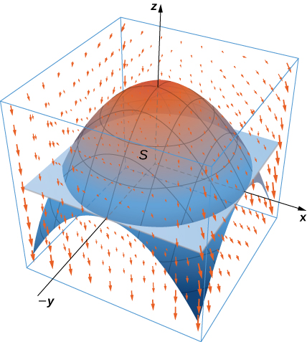

Answer: 

1. Let *E* be the solid unit cube with diagonally opposite corners at the origin and (1, 1, 1), and faces parallel to the coordinate planes. Let *S* be the surface of *E*,oriented with the outward-pointing normal. Use a CAS to find  using the divergence theorem if .

Answer: 

1. Use the divergence theorem to calculate the flux of  through sphere 

Answer: 

1. Find  where and *S* is the outwardly oriented surface obtained by removing cube  from cube 

Answer: 

1. Consider radial vector field  Compute the surface integral, where *S* is the surface of a sphere of radius *a* centered at the origin.

Answer: 

1. Compute the flux of water through parabolic cylinder  from , if the velocity vector is .

Answer: 

1. **[T]** Use a CAS to find the flux of vector field  across the portion of hyperboloid  between planes  and  oriented so the unit normal vector points away from the *z*-axis.

Answer: 

1. **[T]** Use a CAS to find the flux of vector field  through surface *S*, where *S* is given by  from  oriented so the unit normal vector points downward.

Answer: 

1. **[T]** Use a CAS to compute , where  and *S* is a part of sphere  with 

Answer: 

1. Evaluate , where  and *S* is a closed surface bounding the region andconsisting of solid cylinder  and 

Answer: 

1. **[T]** Use a CAS to calculate the flux of  across surface *S*, where *S* is the boundary of the solidbounded by hemispheres and , and plane 

Answer: 

1. Use the divergence theorem to evaluate , where  and *S* is the surface consisting of three pieces:  on the top;  on the sides; and  on the bottom.

Answer: 

1. **[T]** Use a CAS and the divergence theorem to evaluate , where  and *S* is sphere  orientated outward.

Answer: 

1. Use the divergence theorem to evaluate , where  and *S* is the boundary of the solid enclosed by paraboloid  cylinder  and plane  and *S* is oriented outward.

Answer: 

**For the following exercises, Fourier’s law of heat transfer states that the heat flow vector F at a point is proportional to the negative gradient of the temperature; that is,  which means that heat energy flows hot regions to cold regions. The constant  is called the *conductivity*, which has metric units of joules per meter per second-kelvin or watts per meter-kelvin. A temperature function for region *D* is given. Use the divergence theorem to find net outward heat flux  across the boundary *S* of *D*, where ** .

1.  

Answer: 

1.  

Answer: 

1.  *D* is the sphere of radius *a* centered at the origin.

Answer: 

**Chapter Review Exercises**

***True or False.* Justify your answer with a proof or a counterexample.**

1. Vector field  is conservative.

Answer: False

1. For vector field , if  in open region, then .

Answer: True

1. The divergence of a vector field is a vector field.

Answer: False

1. If , then  is a conservative vector field.

Answer: False

**Draw the following vector fields.**

1. 

Answer:

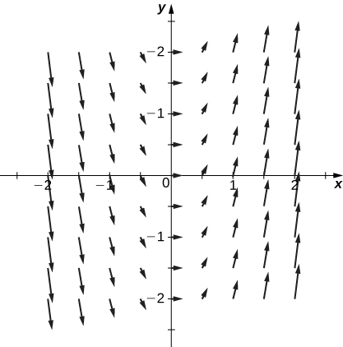

1. 

Answer:

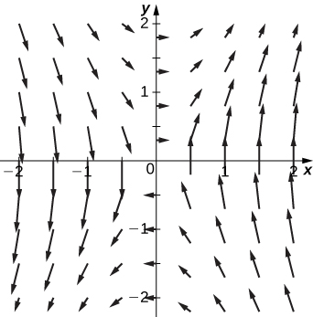

**Are the following the vector fields conservative? If so, find the potential function *f* such that **

1. 

Answer: Conservative, 

1. 

Answer: Conservative,

1. 

Answer: Conservative, 

1. 

Answer: Not conservative

**Evaluate the following integrals.**

1.  along  from (0, 0) to (4, 2)

Answer: 

1.  where 

Answer: 

1.  where *S* is surface 

Answer: 

**Find the divergence and curl for the following vector fields.**

1. 

Answer: Divergence:  curl: 

1. 

Answer: Divergence:  curl: 

**Use Green’s theorem to evaluate the following integrals.**

1.  where *C* is a square with vertices (0, 0), (0, 2), (2, 2) and (2, 0)

Answer: 

1.  where *C* is a circle centered at the origin with radius 3

Answer: 

**Use Stokes’ theorem to evaluate .**

1. , where  is the upper half of the unit sphere

Answer:

1. , whereis the upward-facing paraboloid  lying in cylinder 

Answer: 

**Use the divergence theorem to evaluate .**

1. , over cube  defined by ,,

Answer: 

1. , where  is bounded by paraboloid and plane

Answer: 

1. Find the amount of work performed by a 50-kg woman ascending a helical staircase with radius 2 m and height 100 m. The woman completes five revolutions during the climb.

Answer:  N

1. Find the total mass of a thin wire in the shape of a semicircle with radius  and a density function of 

Answer: 

1. Find the total mass of a thin sheet in the shape of a hemisphere with radius 2 for  with a density function 

Answer:]

1. Use the divergence theorem to compute the value of the flux integral over the unit sphere with .

Answer: 

This file is copyright 2016, Rice University. All Rights Reserved.